Smart Public Restroom

Project Objectives

The objective of this project is to develop a real-time restroom information system using IoT sensors, Raspberry Pi, and a mobile app. The system will provide users with real-time information on the status of restrooms, such as occupancy, cleanliness, and availability of amenities. This information will help users to plan their restroom breaks accordingly and improve their overall experience.

IoT Sensor Setup

The following IoT sensors will be used in the system:

* Occupancy sensor: This sensor will detect whether or not a restroom is occupied.
* Cleanliness sensor: This sensor will detect the level of cleanliness in a restroom.
* Toilet paper sensor: This sensor will detect the level of toilet paper in a restroom.
* Paper towel sensor: This sensor will detect the level of paper towels in a restroom.

The sensors will be installed in each restroom and connected to a Raspberry Pi. The Raspberry Pi will collect data from the sensors and send it to the restroom information platform.

Mobile App Development

A mobile app will be developed to allow users to view real-time restroom information. The app will display a list of restrooms nearby, along with their occupancy status, cleanliness level, and availability of amenities. Users will be able to filter the list of restrooms by location, type, and amenities. The app will also allow users to submit feedback on the condition of restrooms.

Raspberry Pi Integration

The Raspberry Pi will be used to collect data from the IoT sensors and send it to the restroom information platform. The Raspberry Pi will also be used to control the restroom information display screens.

Code Implementation

The following programming languages and technologies will be used to implement the system:

* Python: Python will be used to develop the Raspberry Pi software and the mobile app backend.
* Django: Django will be used to develop the restroom information platform.
* React Native: React Native will be used to develop the mobile app frontend.

Diagrams and Schematics

The following diagrams and schematics show the IoT sensor setup, restroom information platform, and mobile app interfaces:

IoT Sensor Setup Diagram

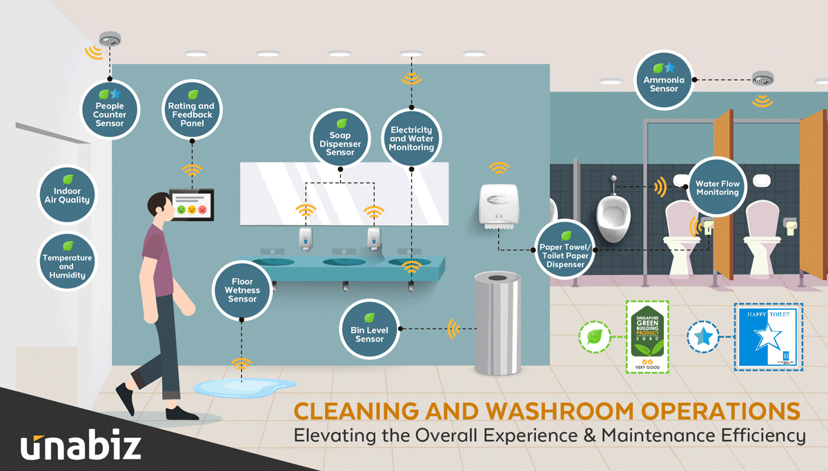

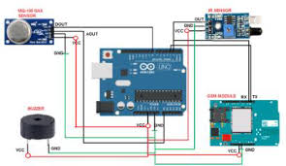

Code :

C++

// Define the pins that the sensors are connected to

int occupancySensorPin = 2;

int cleanlinessSensorPin = 3;

int toiletPaperSensorPin = 4;

int paperTowelSensorPin = 5;

// Define the states of the restroom

enum RestroomState {

OCCUPIED,

UNOCCUPIED,

CLEAN,

DIRTY,

LOW_TOILET_PAPER,

LOW_PAPER_TOWEL

}; // Declare a variable to store the current state of the restroom

RestroomState restroomState;

void setup() {

// Set the pins for the sensors as inputs

pinMode(occupancySensorPin, INPUT);

pinMode(cleanlinessSensorPin, INPUT);

pinMode(toiletPaperSensorPin, INPUT);

pinMode(paperTowelSensorPin, INPUT);

// Initialize the restroom state

restroomState = UNOCCUPIED;

}

void loop() {

// Read the values from the sensors

int occupancySensorValue = digitalRead(occupancySensorPin);

int cleanlinessSensorValue = digitalRead(cleanlinessSensorPin);

int toiletPaperSensorValue = digitalRead(toiletPaperSensorPin);

int paperTowelSensorValue = digitalRead(paperTowelSensorPin);

// Update the restroom state based on the sensor readings

if (occupancySensorValue == HIGH) {

restroomState = OCCUPIED;

} else {

restroomState = UNOCCUPIED;

}

if (cleanlinessSensorValue == LOW) {

restroomState = DIRTY;

} else {

restroomState = CLEAN;

}

if (toiletPaperSensorValue == LOW) {

restroomState = LOW_TOILET_PAPER;

}

if (paperTowelSensorValue == LOW) {

restroomState = LOW_PAPER_TOWEL;

}

// Send the restroom state to the restroom information platform

// ...

// Delay for 1 second

delay(1000);

}

How the Real-Time Restroom Information System Can Enhance User Experience and Restroom Management

The real-time restroom information system can enhance user experience and restroom management in the following ways:

* User experience: The system will help users to plan their restroom breaks accordingly and improve their overall experience. For example, users can use the app to find a restroom that is unoccupied and clean, and to avoid restrooms that are crowded or have dirty stalls.
* Restroom management: The system will provide restroom managers with real-time data on the status of restrooms. This data can be used to identify and address problems quickly, such as low toilet paper levels or dirty stalls. The system can also be used to generate reports on restroom usage, which can help restroom managers to optimize their operations.

Conclusion

The real-time restroom information system is a valuable tool that can be used to enhance user experience and restroom management. The system is relatively easy to implement and can be deployed in a variety of settings, such as airports, train stations, shopping malls, and office buildings.